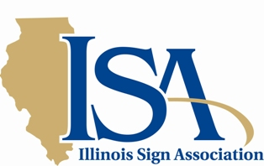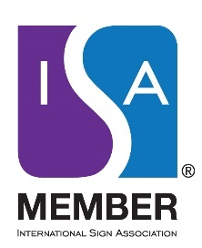

8 West Monroe Street Suite 707 Chicago, Illinois 60603 312-881-9920 isa-sign.com office@isa-sign.com

NEWS RELEASE
August 21, 2020

CHICAGO, IL…The Illinois Sign Association is announcing that the live, in-person 2020 Illinois Sign Expo, Education Conference and Awards Dinner slated for September 20-30 has been cancelled. It will be replaced by a series of virtual meetings in September, October, and December. The decision by the fall conference planning committee was reached after reviewing the results of an all member survey which clearly indicated the best choice was to cancel until next year.

Conference Chair, Tabita Bowen of All-Right Sign stated “We are keenly aware that the value of the association membership rests with interactions among fellow sign companies and allied trades. ISA we will continue to promote activities to build on relationships, networking, education, and advocacy.”

ISA President John Johnson of C. Johnson Sign Co. noted “The hand writing was on the wall and this was clearly the right decision during these most unprecedented times.”

Although cancelled until 2021, in its place, members will be invited to virtual “Meet and Greets” featuring product updates and social networking presented on a regular basis throughout the year.

The first virtual meet and greet networking hour will be conducted on Tuesday, September 29 at 3:00 PM via the interactive zoom platform. Members will be invited to respond to a series of questions related to business affairs, industry marketplace and other general information of value for those who are facing the same challenges in the same industry.

For more information about the Illinois Sign Association refer to its website at isa-sign.com

# # #

