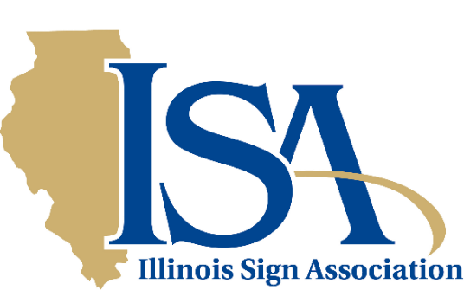

Helping You Achieve Your Company Goals

The Illinois Sign Association was founded in 1969 to elevate and promote the standards and professionalism of the custom electric sign industry in sales, manufacturing and service.

- Networking
- Communication
- Education
- Industry Trends
- Awards
- Legislative Assistance
Our members epitomize the very best the industry has to offer its customers, the viewing public and the communities where our products and services are marketed.

Our abiding concern with the aesthetics of a community have prompted us to work with local officials in a cooperative effort to develop acceptable, but realistic zoning and sign codes.

Through our association of sign companies, sign users, sign supply distributors, sign manufacturers and manufacturer representatives, we strive daily to provide the latest information and newest technologies, effective business strategies and legislative developments that impact the industry.

Conferences, special training seminars, a quarterly newsletter and various other informational publications keep the membership abreast of what they need to know. ISA also acknowledges excellence of design and individual achievement through special award programs and peer recognition.

For over 50 years, ISA has stood tall as a professional trade association, serving the ever changing needs of its members and the customers they serve. It has been a partnership of which we are indeed proud!

Ten Important Reasons to join the Illinois Sign Association and International Sign Association

- iMAGES Digital – Receive regular updates and news about the people, events and latest sign industry technologies that you won’t find in the national magazine.
- Member Conferences to learn, socialize and effectively network with our peers.
- ISA Web site: www.isa-sign.com - Customers will find you here as a member of the state’s only professional association for on-premise signage. Many tools for you to use, too!
- Sign Design Contest - Awards for your creative output as well as distinguished service to the industry.
- Special training seminars for you, your supervisors and technicians in such diverse areas as computer technology, OSHA safety certification, sign lighting and crane/ladder operations.
- Annual Membership Directory - A veritable “who’s who” of the finest sign companies and industry vendors that belong to the Illinois Sign Association.
- Legislative monitoring and advocacy - promoting less regulation and greater government recognition of the problems encountered by small businesses.
- Industry dialog with community leaders, including sharing of vital sign ordinance information with local planners and other key officials.
- Special publications distributed, often free of charge, to the members to keep them abreast of governmental regulations, new technologies and unique growth opportunities.
- Finally - and perhaps most importantly - being part of a special fraternity of professionals who are among the finest sign makers in Illinois - members of the Illinois & International Sign Associations
A JOINT MEMBERSHIP FOR SIGN COMPANIES.

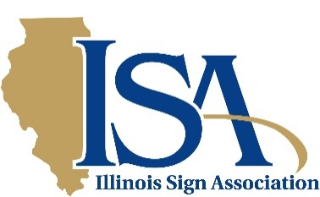

The Benefits of Membership

Legislative Assistance By networking with member companies, taking advantage of national resources and expertise and by working with state and municipal government officials, sign industry interests are expressed and advanced.

Networking
At association conferences, owners and managers swap new ideas, learn of emerging technologies and business strategies and gain recognition and support from their peers. Time is also allowed for welcome social activities.

Special training seminars are also held from time to time to offer the latest technology and shop techniques to various member employees.

Communication
A quarterly newsletter, special legislative advisories and an annual directory provide member firms with timely, helpful and informative data about the industry: its people, products and problems. Up-todate information can also be found on the association’s Web site and obtained via the E-mail list server.

Economic Advantages
Low cost training is available for you and your employees.

Industry Advantages
Opportunities are readily available to assume leadership positions within the association and thereby work with other respected industry movers and shakers in shaping the future of our respected profession. ISA continually encourages bold, new innovations and strives relentlessly to keep its members current with this rapidly changing industry.

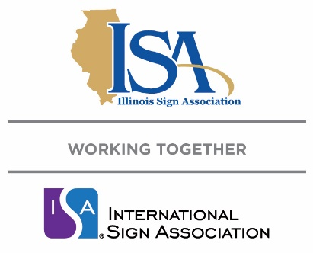

APPLICATION FOR MEMBERSHIP

ELIGIBILITY FOR MEMBERSHIP
Any Firm (Corporation, Partnership, Individual) that sells, manufactures, installs or services signs of any description; sells products or services used in the sign industry; any person retired from such firm; or any sign user shall be eligible for membership under the assigned membership category.

ANNUAL RATE OF DUES
(Please check appropriate classification)
Note: 2 part-time employees equal 1 full-time employee. Please calculate accordingly.

Sign Companies (* includes membership in both Illinois and International Sign Associations)
1- 5 Employees $200 *
6-10 Employees $475 *
11-15 Employees $650 *
16+ Employees $850 *

Sign Product Manufacturers $399
Supply Distributors $499
Manufacturer Reps. $299
Sign Users $ 50
Retiree Members $ 25

A full year's dues must accompany application. Application for membership implies willingness to comply with the by-laws, regulations, purposes and objectives of the Illinois Sign Association. Sign Companies receive membership in both Illinois and International Sign Association. Other membership categories must join each association separately.

Company

Name _____________________________________Title __________________________E-mail

Add’l Contact _______________________________Title __________________________E-mail _____________________________

Address City State Zip

Phone ( ) Website

We accept checks, Visa, MasterCard, AMEX, Discover cards and PayPal. Please complete and return by email or USPS mail.

Amount $___________

Card Number _______________________________ Expiration Date ____/____ mm/yy 3or 4-digit security code __ __ __ __

Name as shown on card _______________________________________________

Company____________________________________________________________

Credit Card Billing Address __________________________________________City___________________ State____ Zip__________

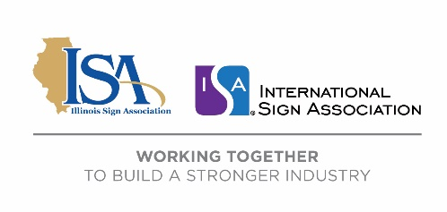
Return you completed application and payment to:

Illinois Sign Association
8 W. Monroe Street – Suite 707
Chicago, Illinois 60603 312-881-9920

The Illinois Sign Association is an International Sign Association affiliated state association.
Please note that the charge on your credit card statement will be to the Illinois Sign Association
PLEASE SEE NEXT PAGE FOR ADDITIONAL INFORMATION

FOR MEMBERSHIP & WEBSITE DIRECTORY LISTING (rev. 02/15/2021)
(Please fill in appropriate information)

Locations of other offices or plants:

Officers/Titles:

SIGN COMPANY

Service Available:

Equipment:

Service Area:

MANUFACTURERS’ REPRESENTATIVE

Companies Represented:

Area Served:

SIGN PRODUCT MANUFACTURER

Products:

Area Served:

SIGN SUPPLY DISTRIBUTOR
Products:

Area Served:

